## Kingdom Documentation

**Such Life**

# 

# **[Kingdom Info]**

The kingdom serves as a sort of hub for the player. It is designed with room for expandability in the future. It features several unique buildings with differing utility to the player, and many NPCs for the player to interact with.

# **[Kingdom Buildings]**

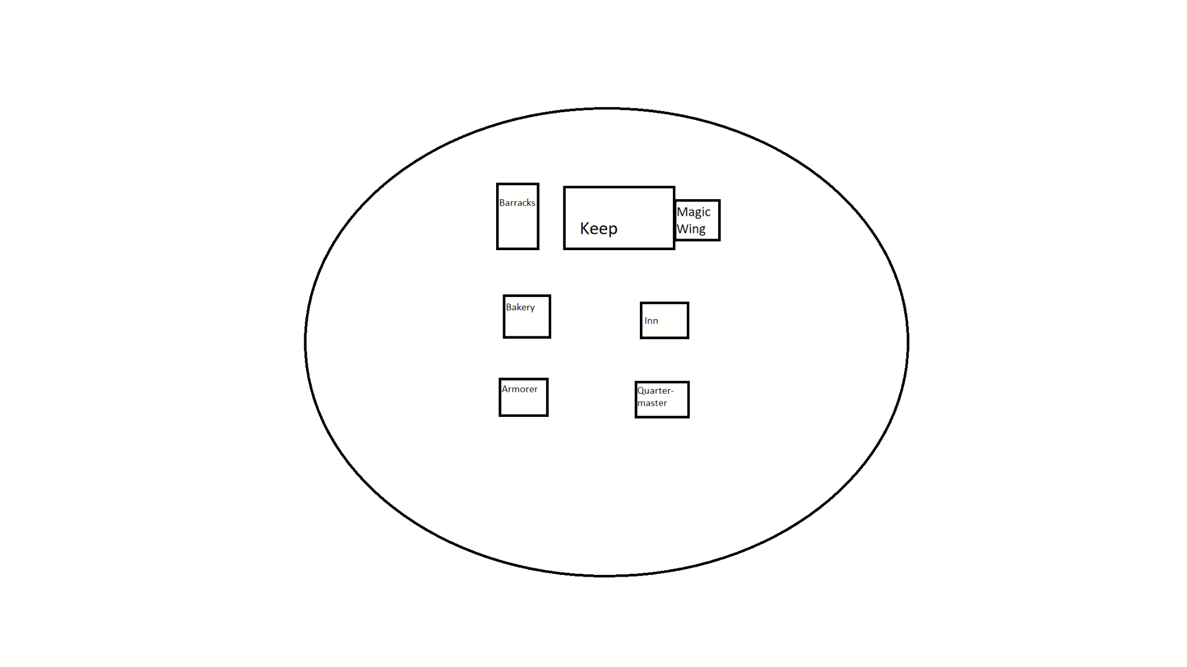

Unique buildings

Keep:

The keep is the primary castle in the kingdom, allowing the player to manage their reputation with the kingdom.

Magic Wing:

The magic Wing, attached to the keep, allows the player to work on their magic abilities and craft different runes.

Barracks:

Housing for guards. Allows the player to find inexpensive, but low-quality surplus gear.

Bakery:

The player can buy baked goods and other foods here, as well as pay to use the cooking facilities.

Inn:

Player housing and storage. Rent a room.

Armorer:  
Houses the armorer NPC, With whom the player can buy and sell armor.The player can also pay to use tools to craft armor. The Armorer also offers magic distress signals, providing the location of an NPC in need of help, to earn currency and raise reputation.

Quartermaster:

Houses the quartermaster NPC, With whom the player can buy and sell weapons.The player can also pay to use tools to craft weapons. After a certain level, the quartermaster will sell tower dungeon keys of differing types, allowing the player to access the tower dungeon.